**House Number** **5**

Bansko, Blagoevgrad district, 4 Dame Gruev Str.

GPS N 41°49'56.2" and E 23°29'05.4"

The house is with 4 floors with basement. The stairs are internal stairs for a building. The basement is only of the part of the house under the kitchen and corridor. The family lives on the first and second floors. This city is a ski resort and the family rent the suites and rooms on the 3 and 4th floors during the winter and for holiday in the summer.

2 - PCH (brown); 3 – MDC (yellow); 4 – MCH (Black) and 4 – CATS

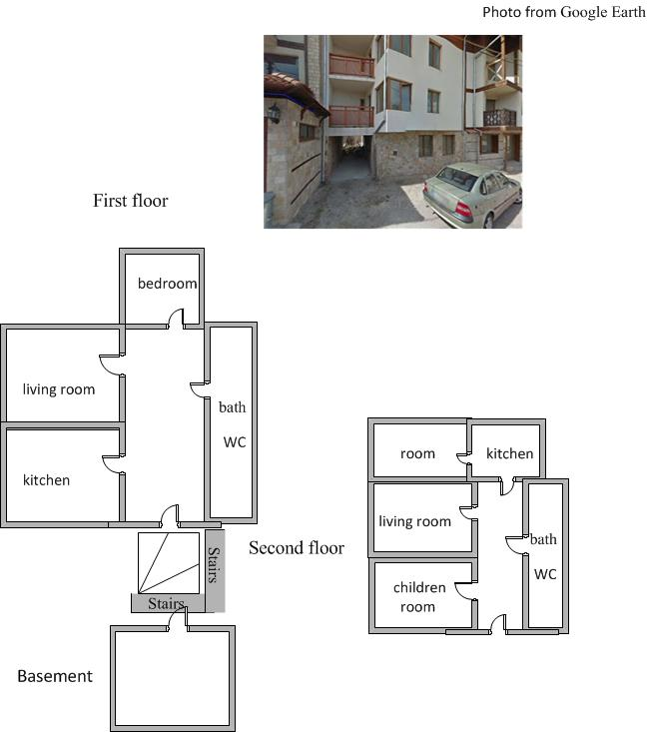

RADOSYS-RSFV

pair of CATS

relevant GTS